Profile
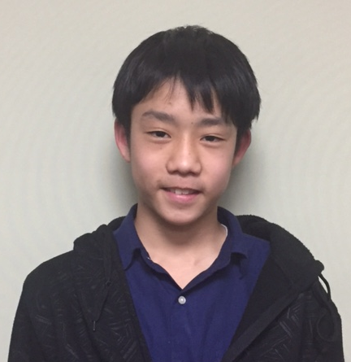
Name: Kawamura Taishiro
family name given name
Nationality: Japan
Birth date: 02/10/2002 (day/month/year)
Age: 14 Sex: male
School (year): 8th grade of Fuzoku Yamaguchi Junior High School

Family (name, age and occupation)
Father: Yosuke, 45 office worker
Mother: Rie, 43 office worker
Siblings: Natsumi, 16 high school student

Allergy: None Religion: Buddhist

Message
Dear Family,
Thank you very much for becoming my host family.
My name is Taishiro Kawamura, please call me Taishiro. I’m a member of the basketball club in my school, and I like playing basketball very much. I would like to see the game and play it, if possible.
I am very excited to go to the United States this spring. I want to see the scenes I can’t see in Japan. I want to go to the beach and forest, and take a lot of pictures.
I’m looking forward to seeing you.
Sincerely,
河村太志朗

